United

**Course Conversion Tool**

**March 16, 2012**

Primary Contact

Dean Biele, CTO

(508) 624-9100 [dbiele@invisionlearning.com](mailto:dbiele@invisionlearning.com)

United Course Conversion Tool:

The Course Conversion Tool is used to convert Continental Templates into United Templates:

* Update XML
* View XML
* Build Timeline

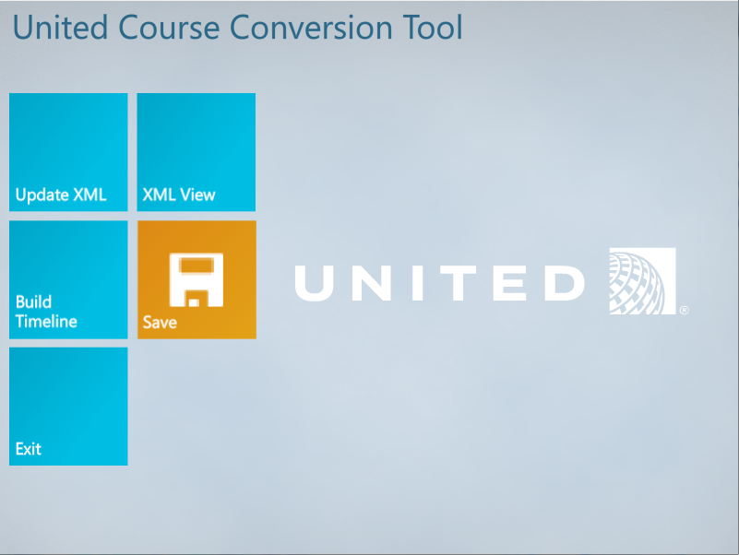

Security Settings:

The course conversion tool may require administrator privileges to open and save data. If you encounter problems opening the files please verify user privileges on the computer.

Getting Started:

1. Install the “United Course Conversion Tool.mxp” onto a local computer using the Adobe Extension Manager.
2. Locate the “old” course you would like to convert. Use Windows Explorer to find the folder. We will be copying files from this folder to the new updated course.
3. Create a new folder for the new updated course. This folder will contain all course files and will be structured very similar to the previous templates. Creating a new area for the updated course keeps things simply.
4. Copy the media folder from the old course to the new course folder.
5. Open a new United Template in Flash Professional. File > New > Templates > United WBT Templates.

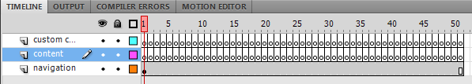

1. Save the new United Template .FLA to the new course folder. You can use any name for the .FLA file. This is the same approach as the previous templates.
2. You are now ready to convert the old course to the new format.

Converting Course:

The united course conversion tool updates the content.xml from the old course and creates a new FLA timeline in Flash. The folder structure for the new templates is identical to the old templates.

Instructions to convert course:

1. Make sure the new course .fla is open.
2. Open the United Course Conversion Tool in Flash Professional. Commands > United Course Conversion Tool.
3. Select the old courses content.xml. Click the browse button to locate the content.xml.   
   The content.xml file will be updated in the tool and later saved to the new course folder. Changes are only committed when the save button is clicked.
4. Click the “**Update XML**” tile to update the content.xml.
5. XML View is used to view the modified xml. This step is optional.
6. Click the “**Build Timeline**” tile to create a new timeline in the open .FLA. Make sure to Update XML before doing this step.
7. Click the “**Save**” tile to save the updated content.xml. Save the file as “content.xml” and save into the new course folder. Do not overwrite the old course content.xml.
8. Click “**Exit**” to return to the Flash Professional timeline.

The course has now been converted. Please save the updated .fla file. You are now ready to edit the course.

Notes:

1. The old course menu template is removed automatically. This template is not used in the latest templates. It is replaced by the menu button in the course navigation bar.
2. Fonts have been updated to Arial. Previous version was Myriad Pro.
3. The “00 Course Introduction” template is automatically added to the first frame of the course.

Check List:

* Update position of highlights when used with background images. Please review pages where background images and highlights are used together. Image areas are not the same size as previous templates. Because of the difference in size, background images are positioned differently. Update the position of the highlights where necessary.
* You may want to remove the “Lesson Complete” from the timeline. The purpose of the lesson complete in the old templates was to notify the learner that they must return to the main menu. Since the main menu does not exist as a frame in the timeline, you may want to remove of modify this page.
* Verify special characters (ie &) appear correctly in the course. If they are not appearing properly, use the template UI to make the update.
* When first trying to publish the course after using the Course Conversion Tool you may receive the following error. If the error appears, click thru each frame of the main timeline. After clicking on all frames, the error is resolved.